Bangkok -Kanchaburi 4day3night (private)
Highlight: Damnean saduk floating Market / Malika village /River bridge / Skywalk / afternoon tea
Tour code: KAN -04
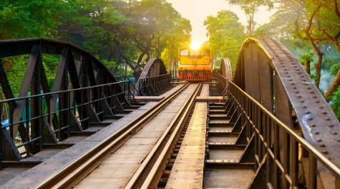
Itinerary
Day1: ARRIVE Bangkok Airport for your flight departure to Bangkok
- Meet and great at the airport with the professional tour guide
- Send to Hotel check in, Shopping Joodfair Night market Dinner by their own

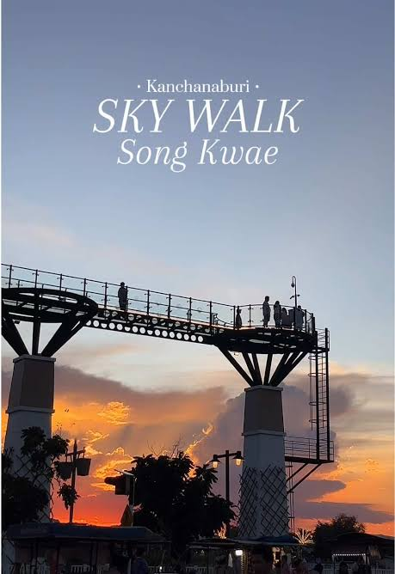
Day2: Bangkok -Dannean saduk -Kanchanaburi (Breakfast /lunch /Dinner)
- Transfer to Dannean saduk floating market, Mae klong railway station, lunch at local restaurant
- After to Kanchanaburi (approx. 1 hrs.)
- River Kwai Bridge Railway – Take photos and enjoy the scenic view of the River Kwai.
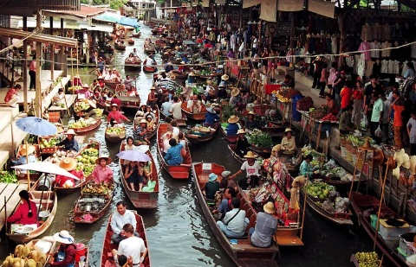
- River Kwai Sky Walk — A scenic glass bridge offering breathtaking panoramic views where the Kwai Noi and Kwai Yai rivers meet. Visitors can enjoy walking above the river and capturing stunning photos of the surrounding landscape.
- Check-in at Kanchanaburi Resort

Day3: Kanchanaburi – Bangkok (Breakfast / Lunch /Dinner by own)
- Breakfast at hotel
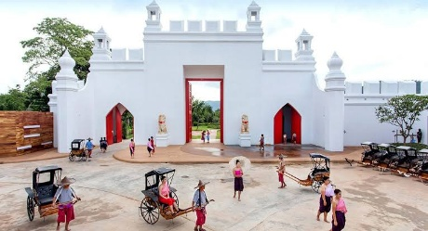
- Malika Village Malika R.E.124 Village is a cultural-tourist attraction where you can experience Thai traditional lifestyle
- Lunch at local restaurant,
- transfer to hotel check in at Bangkok
- Afternoon tea at Niagara N Garden * Complementary 1drink *
- Central Park new shopping mall or BIG C supermarket
- Dinner by own
- Overnight stay at Bangkok Hotel
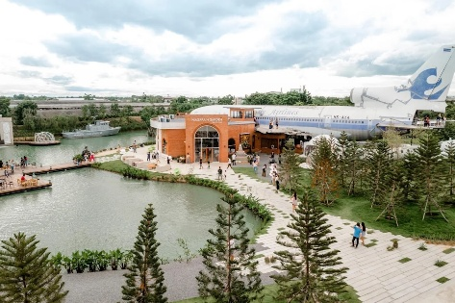
Day4: Bangkok -Dept
- Breakfast at Hotel
- After free leisure time and transfer to Airport for flight back your country,
- sweet Home

